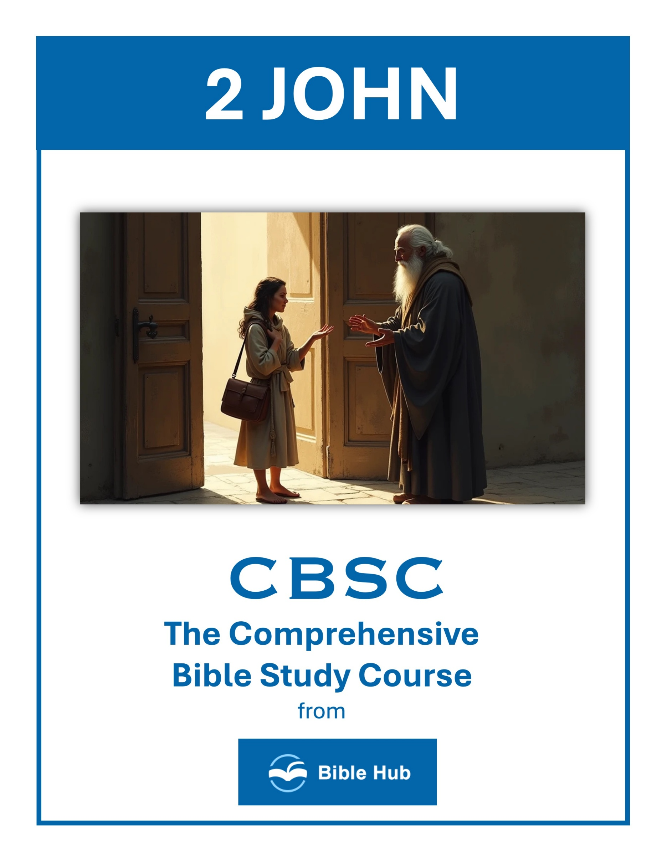

2 John 1 Teaching Points and Bible Study Questions
Walk in Truth
In a world filled with shifting values and fleeting truths, 2 John 1:4 reminds us of the joy found in walking in truth. "I was overjoyed to find some of your children walking in the truth, just as the Father has commanded us." Embrace the truth of Scripture as your compass, guiding your decisions and actions. Let the Word of God be the foundation upon which you build your life, ensuring that your path aligns with His eternal wisdom.
1. How can you ensure your daily actions align with walking in truth?
2. Why do you think walking in truth is essential for personal growth?
3. What steps can you take to encourage others to walk in truth?
Love One Another
The call to love is timeless and central to our faith. 2 John 1:5 urges us, "And now I ask you, dear lady—not as a new commandment to you, but one we have had from the beginning—that we love one another." This love is not just a feeling but an action, a commitment to care for others as Christ cares for us. Let love be the hallmark of your interactions, reflecting the love of Jesus to everyone you meet.
1. How can you demonstrate love to others in your daily interactions, as encouraged in 2 John 1?
2. Why do you think loving one another is emphasized as a commandment in 2 John 1?
3. What practical steps can you take to ensure your love for others aligns with the teachings in 2 John 1?

Obey His Commandments
Obedience is a natural outflow of love. 2 John 1:6 states, "And this is love: that we walk according to His commandments." Following God's commandments is not burdensome but a joyful expression of our relationship with Him. As you align your life with His will, you will find peace and purpose, knowing you are living in harmony with His divine plan.
1. How can you incorporate obedience to God's commandments into your daily routine effectively?
2. Why do you think obedience to God's commandments is essential for a fulfilling spiritual life?
3. What practical steps can you take to ensure you consistently follow God's commandments?
Beware of Deceivers
In a world where false teachings abound, vigilance is crucial. 2 John 1:7 warns, "Many deceivers have gone out into the world, refusing to confess the coming of Jesus Christ in the flesh. Any such person is the deceiver and the antichrist." Stay grounded in Scripture and be discerning, so you can recognize and reject teachings that stray from the truth of the Gospel.
1. How can you discern truth from deception in your daily interactions and relationships?
2. Why do you think it's important to remain vigilant against deceivers in your community?
3. What steps can you take to protect yourself and others from spiritual deception?

Guard Your Reward
Your spiritual journey is precious, and 2 John 1:8 encourages us to "Watch yourselves, so that you do not lose what we have worked for, but that you may be fully rewarded." Protect your faith and the progress you have made by staying committed to God's Word and His promises. Your reward is not just in this life but in the eternal life to come.
1. How can you actively guard your spiritual reward in daily life according to 2 John 1?
2. Why do you think maintaining truth is crucial for preserving your reward as mentioned in 2 John 1?
3. What practical steps can you take to avoid losing your reward as warned in 2 John 1?
Abide in the Doctrine of Christ
Staying true to the teachings of Christ is essential. 2 John 1:9 emphasizes, "Anyone who runs ahead without remaining in the teaching of Christ does not have God. Whoever remains in His teaching has both the Father and the Son." Abide in His doctrine, and you will experience the fullness of a relationship with God, enriched by His presence and guidance.
1. How can you ensure your daily actions reflect abiding in the doctrine of Christ?
2. Why do you think abiding in Christ's teachings is crucial for spiritual growth?
3. What practical steps can you take to avoid being misled by false teachings?

Avoid False Teachers
2 John 1:10-11 advises, "If anyone comes to you but does not bring this teaching, do not receive him into your home or even greet him. Whoever greets such a person shares in his evil deeds." Be cautious about whom you allow to influence your faith journey. Surround yourself with those who uphold the truth of the Gospel, and be wary of those who seek to lead you astray.
1. How can you discern false teachings in your daily life and protect your faith community?
2. Why do you think it's important to remain vigilant against false teachers in today's world?
3. What steps can you take to ensure you are following true teachings and not being misled?
Joy in Fellowship
The joy of fellowship is a recurring theme in Scripture. 2 John 1:12 expresses the desire for face-to-face interaction: "I have much to write to you, but I do not want to use paper and ink. Instead, I hope to come to you and speak face to face, so that our joy may be complete." Cherish the moments of fellowship with fellow believers, as they strengthen your faith and bring joy to your heart.
1. How can you cultivate joy in fellowship with others in your daily life?
2. Why do you think genuine fellowship brings joy to a community of believers?
3. What can you do to enhance joy in your church or small group gatherings?

The Importance of Family in Faith
2 John 1:13 highlights the role of family in our spiritual lives: "The children of your elect sister send you greetings." Family is a vital support system in our walk with Christ. Encourage and nurture each other in faith, creating a legacy of belief that spans generations.
1. How can you actively involve your family in practicing and growing your faith together daily?
2. Why do you think maintaining truth and love in family relationships is crucial for faith development?
3. What can you do to encourage open discussions about faith within your family?
The Power of Written Encouragement
Finally, 2 John 1 demonstrates the power of written words to encourage and instruct. While face-to-face interaction is invaluable, written communication can also uplift and guide. Consider writing letters or notes to those you care about, sharing Scripture and personal encouragement to strengthen their faith journey.
1. How can you use written encouragement to strengthen relationships within your community today?
2. Why do you think written encouragement holds lasting impact compared to verbal encouragement?
3. What can you do to ensure your written words uplift and inspire others consistently?

